Instructions to run R script for GHG calculations (Windows version)

1. Make sure you have R downloaded
2. Add all needed files to the path. Control panel 🡪 environment variables, add to path

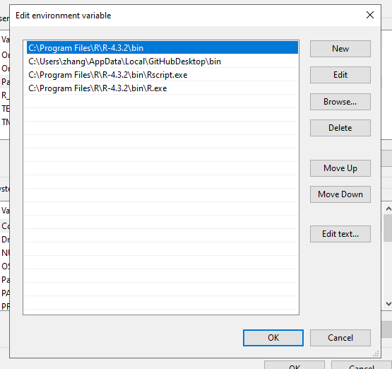

1. Navigate to the folder containing
   1. R script
   2. A folder called “Results”
   3. A folder called “ImportFiles” containing all excel files that needs to be ran. Make sure all column names are the exact to what is needed (following template). Make sure the file names have no spaces in them
2. Type “Rscript VolCalc.R in the command prompt

Basic tips for navigating command prompt in windows

cd -> change directory

cd .. -> move back one step

cd\ -> got to root directory

dir -> list everything in directory

In practicality, open command prompt, enter “cd\”. Copy and paste directory from windows explorer and slay.

Change to d drive

1. cd\
2. D:
3. If you have a specific directory, you may also enter it instead of “D:”
4. Can use “Tab” to navigate.